**Drive-by-Wire system in automobile**

**Drive by wire**

Drive-by-wire technology replaces traditional mechanical and hydraulic systems that control vehicle operations like braking, steering, and acceleration with electronic sensors and actuators. There are several types of drive-by-wire systems, including steer-by-wire, throttle-by-wire, and brake-by-wire. Drive-by-wire aims to increase safety, functionality, and fuel efficiency but introduces complexity that could lead to software or sensor failures and potential accidents if not implemented reliably. While the technology faces challenges, its benefits are ultimately expected to outweigh concerns as it enables enhanced vehicle control and automation.

The drive-by-wire is one of the recently developed technologies in the automotive industry. This ensures completely new driving with new dimensions. It changes bulky and inaccurate mechanical systems with an advanced and accurate electronic system. It is used by many automobile companies all over the world to replace steering control, brake control & throttle control. It also gives designers more space because there is a reduction in mechanical linkages inside the car. Some safety issues of which the people would have to be made aware, such as this system is completely safe as it is being used successfully in civil aircraft & military for years now.

Components of Drive-By-Wire System:

A drive-by-wire car uses

* Electricity,
* Wires,
* variable resistors, a
* And Motor actuators to control functions such as throttle position, gear selection, etcetera. These are usually newer and computer controlled and therefore more efficient.

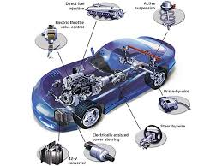

* **Drive by wire** or **DbW** technology in the automotive industry is the use of electronic or electro-mechanical systems in place of mechanical linkages that control driving functions. The concept is similar to [fly-by-wire](https://en.wikipedia.org/wiki/Fly-by-wire) in the aviation industry.Drive-by-wire may refer to just the [propulsion](https://en.wikipedia.org/wiki/Ground_propulsion) of the vehicle through [electronic throttle control](https://en.wikipedia.org/wiki/Electronic_throttle_control),[[3]](https://en.wikipedia.org/wiki/Drive_by_wire#cite_note-Scheibert2023-3) or it may refer to electronic control over propulsion as well as steering and braking, which separately are known as [steer by wire](https://en.wikipedia.org/wiki/Steer_by_wire) and [brake by wire](https://en.wikipedia.org/wiki/Brake_by_wire), along with electronic control over other vehicle [driving](https://en.wikipedia.org/wiki/Driving) functions.[[4]](https://en.wikipedia.org/wiki/Drive_by_wire#cite_note-4)
* Driver input is traditionally transferred mechanically to the motor and wheels through a [steering wheel](https://en.wikipedia.org/wiki/Steering_wheel) and [steering column](https://en.wikipedia.org/wiki/Steering_column), [throttle](https://en.wikipedia.org/wiki/Car_controls#Throttle_control), [hydraulic brakes](https://en.wikipedia.org/wiki/Hydraulic_brakes), [brake pull handles](https://en.wikipedia.org/wiki/Parking_brake#Pedal_or_pull_handle) and so on. In drive-by-wire systems, driver input is processed by an electronic control system which controls the vehicle using [electromechanical](https://en.wikipedia.org/wiki/Electromechanical) [actuators](https://en.wikipedia.org/wiki/Actuators). The [human–machine interface](https://en.wikipedia.org/wiki/Human%E2%80%93machine_interface), such as a steering wheel, yoke, accelerator pedal, brake pedal, and so on, may include [haptic feedback](https://en.wikipedia.org/wiki/Haptic_technology) that simulates the resistance of hydraulic and mechanical pedals and steering, including [steering kickback](https://en.wikipedia.org/wiki/Steering_kickback). Components such as the steering column, intermediate shafts, pumps, hoses, belts, coolers, [vacuum servos](https://en.wikipedia.org/wiki/Vacuum_servo) and master cylinders are eliminated from the vehicle. Safety standards for drive-by-wire are specified by the [ISO 26262](https://en.wikipedia.org/wiki/ISO_26262) standard [level D](https://en.wikipedia.org/wiki/Automotive_Safety_Integrity_Level).

Properties

* The [REE](https://en.wikipedia.org/wiki/REE_Automotive) P7-C truck is the first commercially available vehicle to be road-certified in the United States with all by-wire controls, including drive, steer, brake, and park-brake by-wire, collectively called x-by-wire.[[3]](https://en.wikipedia.org/wiki/Drive_by_wire#cite_note-Scheibert2023-3)
* Dispensing with mechanical linkages has several advantages: it reduces complexity and simplifies assembly; simplifies service and tuning; reduces the force required to engage inputs and allows it to be customized with [haptic technology](https://en.wikipedia.org/wiki/Haptic_technology); allows for more [interior design](https://en.wikipedia.org/wiki/Automotive_design#Interior_design) freedom in the placement of input mechanisms; allows for automation of driving functions; reduces cabin noise by eliminating the acoustic linkage to the drive systems; and by reducing floor openings it improves the [crash behavior](https://en.wikipedia.org/wiki/Automotive_safety) of the vehicle.[[6]](https://en.wikipedia.org/wiki/Drive_by_wire#cite_note-Naunheimer2011-6) Because driver inputs can be overridden, safety can be improved by providing computer controlled intervention of vehicle controls with systems such as [electronic stability control](https://en.wikipedia.org/wiki/Electronic_stability_control) (ESC), [adaptive cruise control](https://en.wikipedia.org/wiki/Autonomous_cruise_control_system) and [lane assist systems](https://en.wikipedia.org/wiki/Lane_departure_warning_system).[[2]](https://en.wikipedia.org/wiki/Drive_by_wire#cite_note-Assembly2010-2)
* Each drive-by-wire system leads to more actuator in the vehicle and therefore greater energy consumption. For instance, the drive-by-wire technology adds actuator motors to create the torque needed to turn the wheels, and a feedback transducer to create the "road feel" on the steering wheel.
* Safety considerations require [redundancy](https://en.wikipedia.org/wiki/Redundancy_(engineering)) of driver input sensors, [vehicle communication networks](https://en.wikipedia.org/wiki/CAN_bus), actuators,[[6]](https://en.wikipedia.org/wiki/Drive_by_wire#cite_note-Naunheimer2011-6) and other systems. Automotive safety standards such as [ISO 26262](https://en.wikipedia.org/wiki/ISO_26262) require drive-by-wire [fail-operational and fail-safe](https://en.wikipedia.org/wiki/Safety-critical_system#Reliability_regimes) behaviors

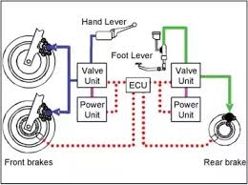

Drive by Wire technology is monumental as it looks to replace the conventional mechanical systems with Electric wires, and uses sensors to record and transmit information to the ECU of the vehicle, where this information is processed and transmitted to the actuators which convert this into mechanical motion. This system is used to control everything from braking to steering and results in a system which is much more effective.

With advances in research and development of this technology over the years, from being used in aircrafts which was called “fly by wire” and later adapted to vehicles to modern day iterations in almost every vehicle currently in the market, the basic ideology of the integration of electronics into mechanical systems of the vehicle and making the job of the driver easier, safer and more comfortable.

Since the idea of every researcher in the industry being to make the vehicle smarter with every passing year, the adoption of drive by wire makes absolute sense. While ensuring improved performance and safety of the vehicle, it is also environmentally responsible too as the addition of a smart system results in better fuel economy as well as emission control. Now as we step into the future, it is imperative for us to fully understand

the applicability of this technology and integrate it to every vehicle, making vehicles safer, cleaner and much more efficient than present day cars.

**BASIC DESCRIPTION**

In a basic Drive by wire system, what we see is the replacement of conventional hydraulics and mechanical linkages with actuators and electrical wires. As a result of this, the weight of the vehicle is significantly reduced as there is no longer the involvement of systems like hydraulics, coolers, hoses, reservoirs etc. In addition to that, there are factors of improved modularity, space management etc., that support this decision of adding these electronic systems. Safety of the vehicles can be increased considerably up to an extent by adding Stability Control features. Electronic cables tend to increase the modularity of the motor vehicle, making it easier to modify or upgrade vehicles. Several features such as Fuel Efficiency, better handling and shortened response time in case of emergency are some of the advantages of Electronic controls.

But even with the advent of such technology, there is always the concern of failure of the same. In any case, fail-proofing every aspect of an electronic system is impossible to perform even with years of experience. So hopefully in the future these limitations are overcome.

**TYPES OF DRIVE BY WIRE SYSTEMS**

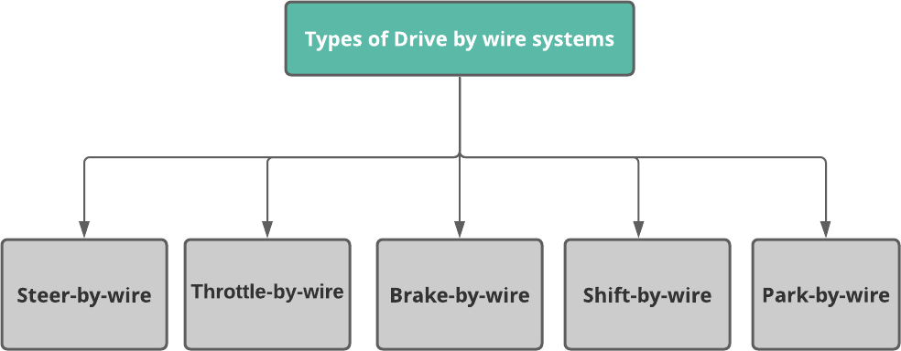

Drive by Wire System in Automobile

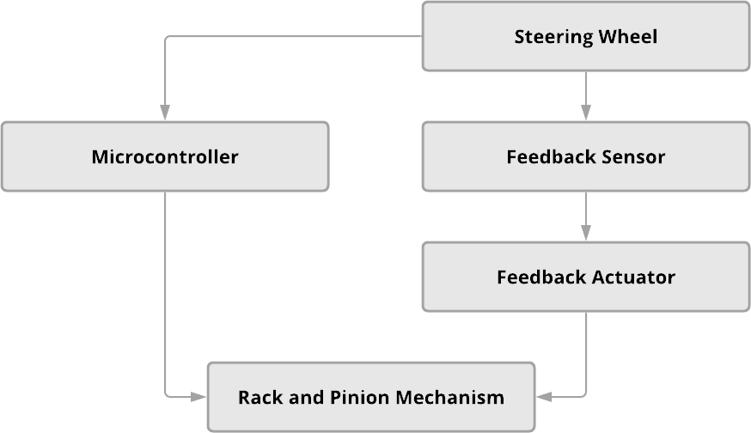

Drive by Wire System in Automobile

# ADVANTAGES AND LIMITATIONS OF DRIVE BY WIRE

With the advent of this system into all our modern vehicles, we have to understand the various boons and banes of the system which currently has already been widely accepted as a valid replacement for the conventional systems in the market today. Among the major advantages included the considerably reduced sizes of various components that help in making the vehicle much more compact and utilize that space for including better fea- tures as well. The modularity of this system is another advantage. A range of vehicles can use the same products and maintain the same quality. The increase in modularity also helps us in reducing manufacturing and operating costs of the product. As all the mechanical linkages are being replaced by electric cables and the considerably more advanced systems being in use, there is higher operational accuracy and conveniently it will help in stretching out the time between service visits for mechanical maintenance and other improvisations. Some of the drive by wire systems need not be maintained for decades, which results in lesser weight and better accuracy that in the end increase the fuel efficiency and fewer emissions. This technology has been tried and tested in the airline industry for decades now and the system's efficiency is certainly extremely evident. Large scale adoption all over the world with all the manufacturers will help limit pollution because of how smart the system can be made. But even with all the advantages of such a revolutionary system, there is always uncertainty involved in it. The fact that many believe that a program is only as good as the programmer. And with a small error in reading the data there is a possibility that the outcome is catastrophic. Consider an error in reading the sensor data in a Brake by Wire system. In such a case, if the brake force is less than or more than the required amount by the driver, it could even lead to an accident. But in reality, the chances of such an error taking place is extremely rare because of how advanced the systems we use today are. Regardless since there is a chance of fatal error in the system, some aspects of Drive by Wire are still under research. And it is only going to get better with more research. Another safety concern is the possibility of remotely hacking the vehicle and taking control of it, making the driver unable to drive safely. But till now, hackers have only been able to activate small systems like windshield wipers etc. But the danger of the same looms large. Considering the fact that most manufacturers have already accepted Drive by Wire as the go to system in their vehicles, and also recognizing that these companies already have done a tone of research and these systems are running successfully, we can put these apprehensions to rest and accept that this system is the future